IIC Calendar Activity

Overall Report on “Eco-Friendly Clay Ganesha Distribution” On_12-09-2026.
Title of The Event |  | Eco - Friendly Clay Ganesha Distribution
Event Convener/ Coordinator & Details |  | Prof. D.Venkatesh, HOD, NSS Programme Coordinaor & Associate Professor,  Department of Civil Engineering,  Narsimha Reddy Engineering College.
Start Date :  End Date :  Duration of the activity : |  | 12-09-2026  12-09-2026  02.00 PM to 05.00 PM
Mode of Session |  | Offline
Number of Student Participants * |  | 250
Number of Faculty Participants * |  | 80
Objective of The Event |  | The primary objective of the “Eco-Friendly Clay Ganesha Distribution” programme was to promote environmental awareness and encourage sustainable celebrations of Ganesh Chaturthi through the use of natural clay idols. The event aimed to:  - Promote the use of eco-friendly clay Ganesha idols to encourage sustainable celebrations.  - Create awareness about reducing water and soil pollution caused by Plaster of Paris idols.  - Encourage environmental responsibility and green practices among students and staff.  - Distribute natural clay Ganesha idols as part of the NSS environmental awareness initiative.  - Strengthen community participation in protecting the environment through eco-conscious festivals.
Outcome workshop/ Benefit in terms of learning/Skill/Knowledge obtained |  | - Students understood the importance of eco-friendly Ganesh Chaturthi celebrations.  - Participants learned the environmental advantages of biodegradable clay idols.  - The program promoted sustainability, social responsibility, and NSS values.  - Faculty and students actively participated in the distribution drive.  - The initiative inspired participants to adopt environmentally friendly practices in future festivals.
Brief Report: |  | The NSS Unit of Narsimha Reddy Engineering College (NRCM) successfully organized the Eco-Friendly Clay Ganesha Distribution programme on 12 September 2026 at Sugunavathi Amphitheatre, NRCM. The event was conducted with the objective of promoting environmentally responsible celebrations by encouraging the use of natural clay Ganesha idols and creating awareness about protecting water bodies from pollution caused by Plaster of Paris (POP) idols.  The programme was inaugurated in the esteemed presence of the Principal, Director, NSS Coordinator Prof. D. Venkatesh, Deans, Heads of all Departments (HODs), faculty members, non-teaching staff, and students. The dignitaries emphasized the importance of sustainable festival practices and encouraged everyone to adopt eco-friendly traditions for the welfare of society and the environment.  As part of the initiative, eco-friendly clay Ganesha idols were distributed to students, faculty, and staff. The NSS volunteers actively coordinated the distribution and explained the environmental benefits of using biodegradable clay idols, highlighting their role in reducing water and soil pollution. The programme witnessed enthusiastic participation from all departments, demonstrating the institution’s collective commitment to environmental conservation and social responsibility.  The event concluded with a vote of thanks and a collective pledge by all participants to celebrate Ganesh Chaturthi in an eco-friendly manner, reinforcing the values of sustainability, community service, and environmental awareness promoted by the NSS Unit.
Poster/ Brochure of the Event |  | 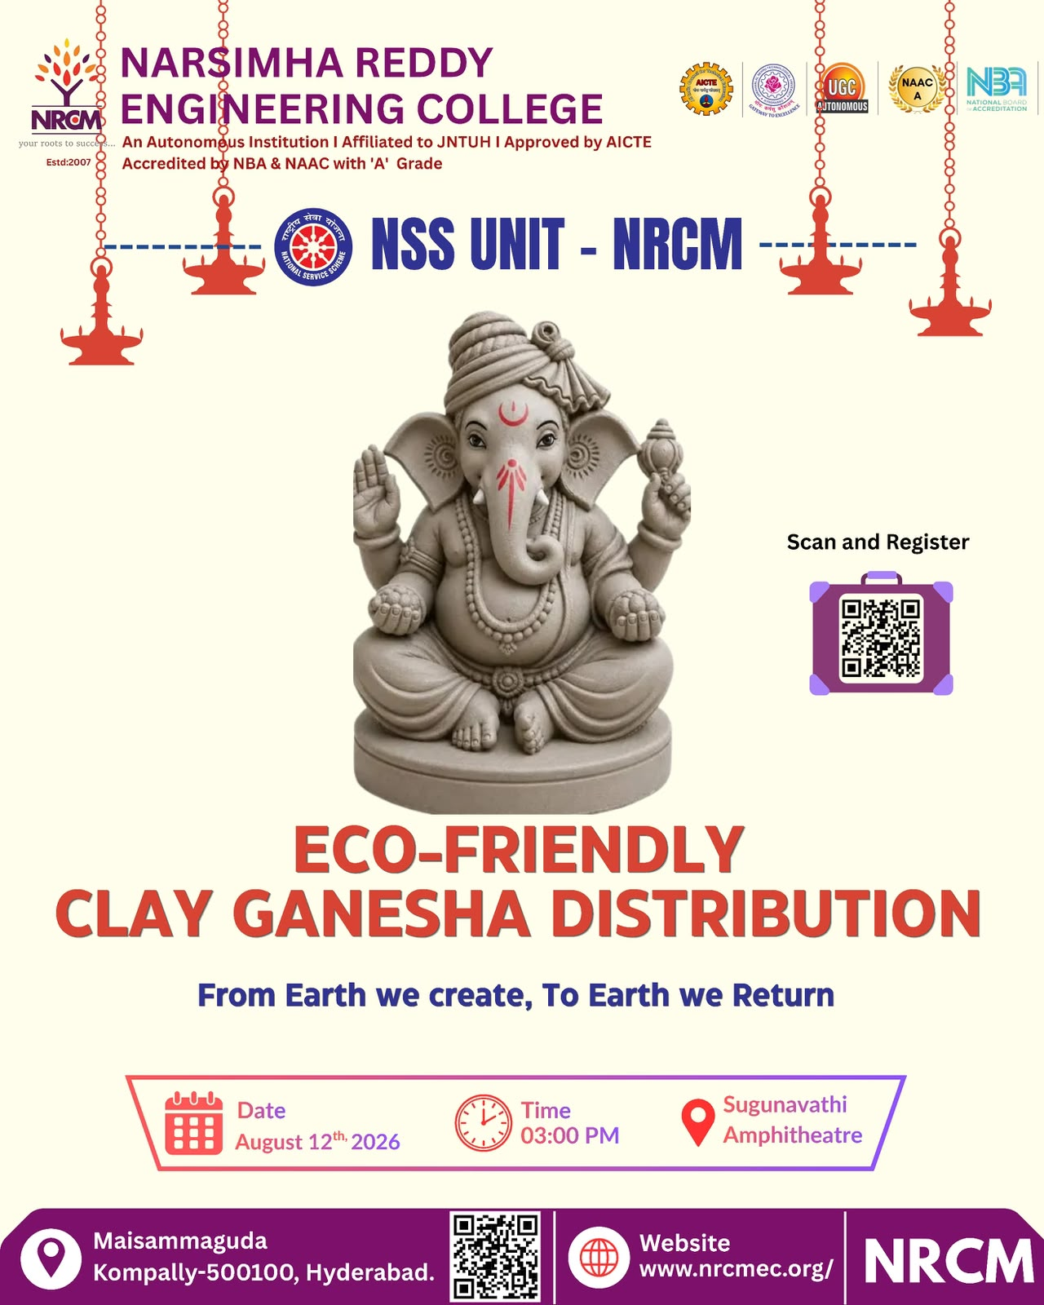
Event Photograph 1 |  | 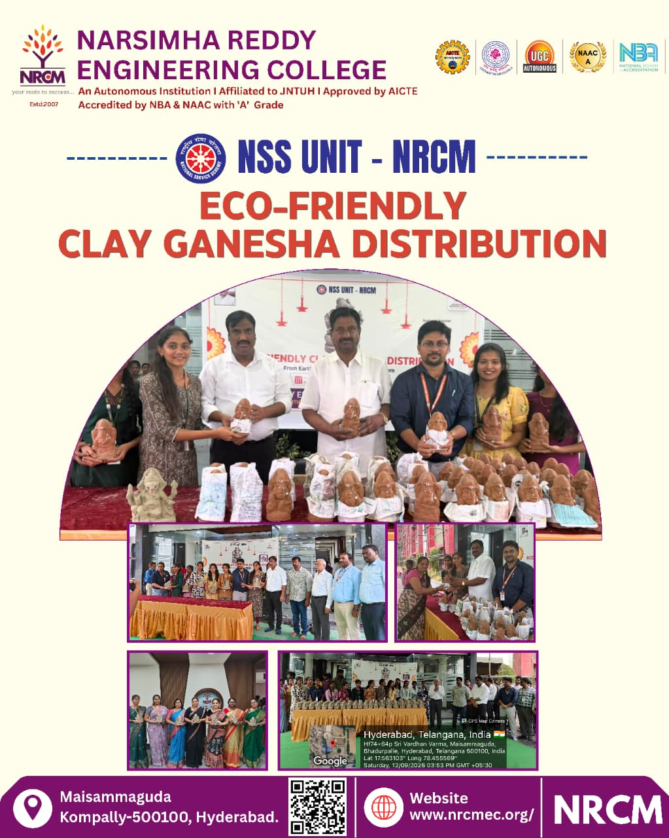
Event Photograph 2 |  | 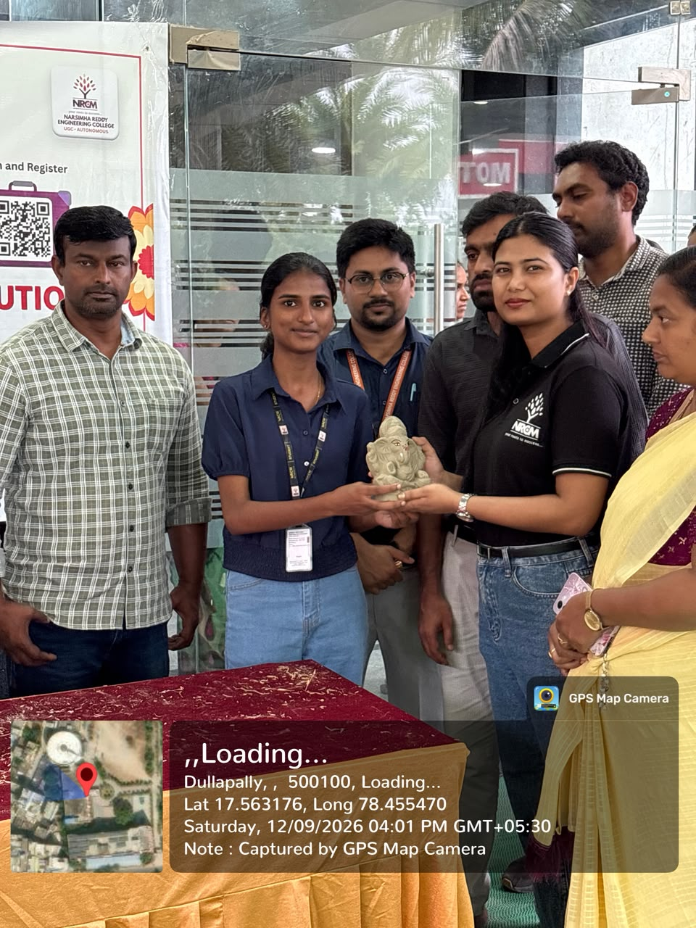
Event Photograph 3 |  | 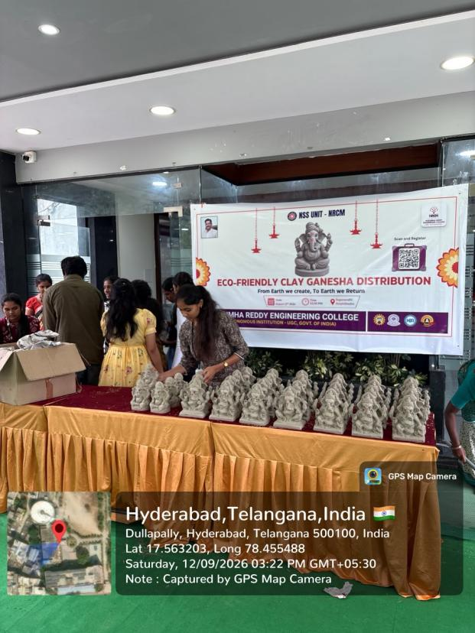
Event Photograph 4 |  | 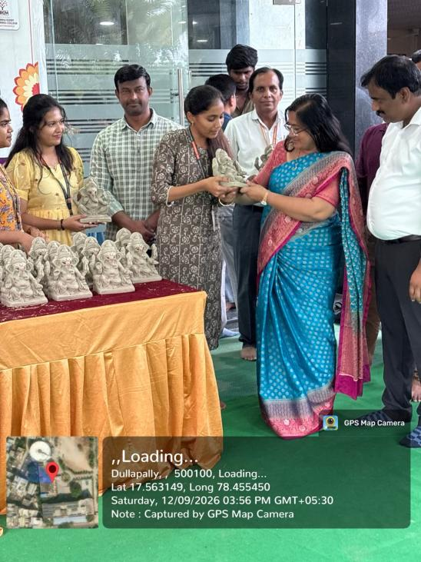
Event Photograph 5 |  | 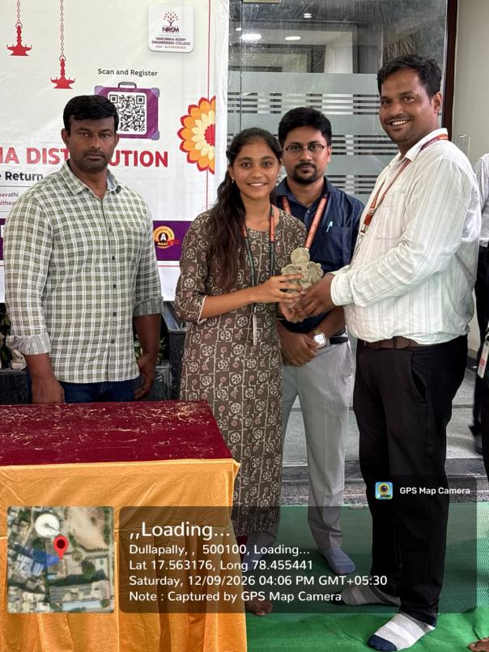
Event Photograph 6 |  | 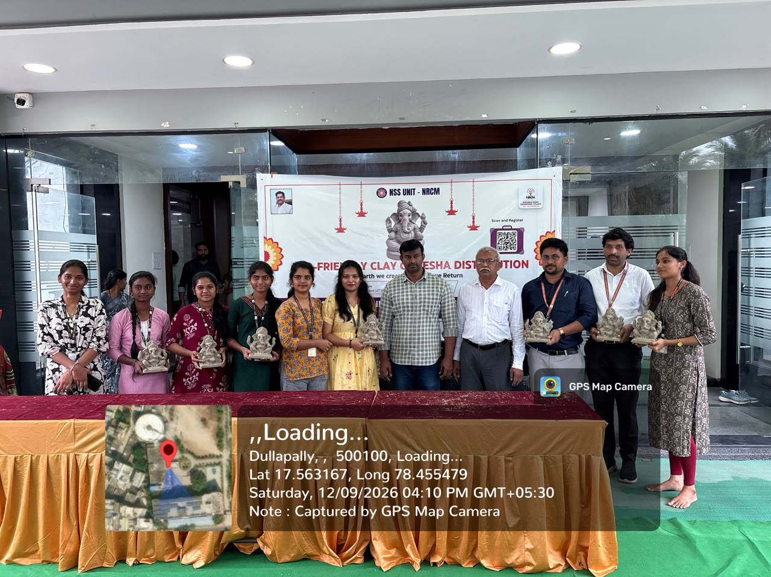
Event Photograph 7 |  | 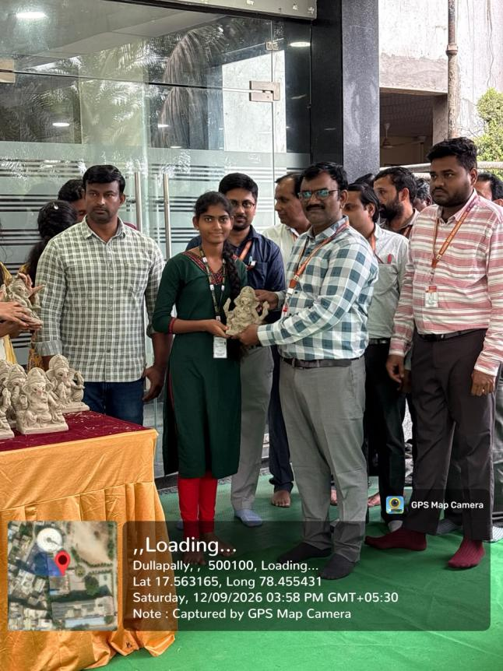
Event Photograph 8 |  | 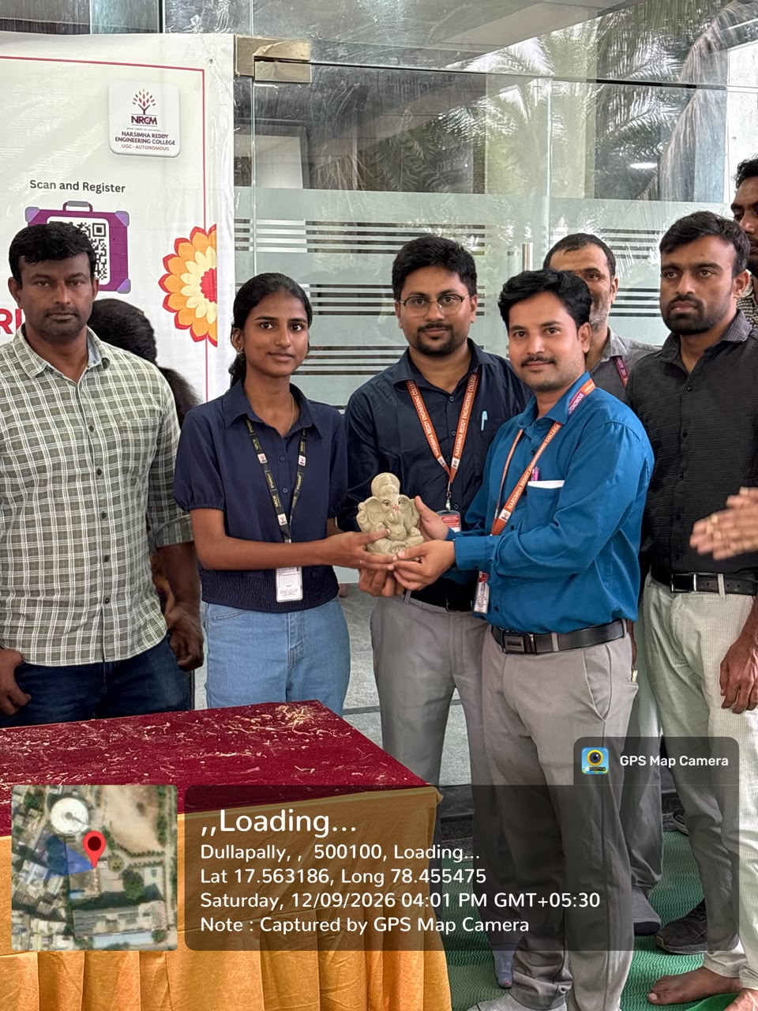
Event Photograph 9 |  | 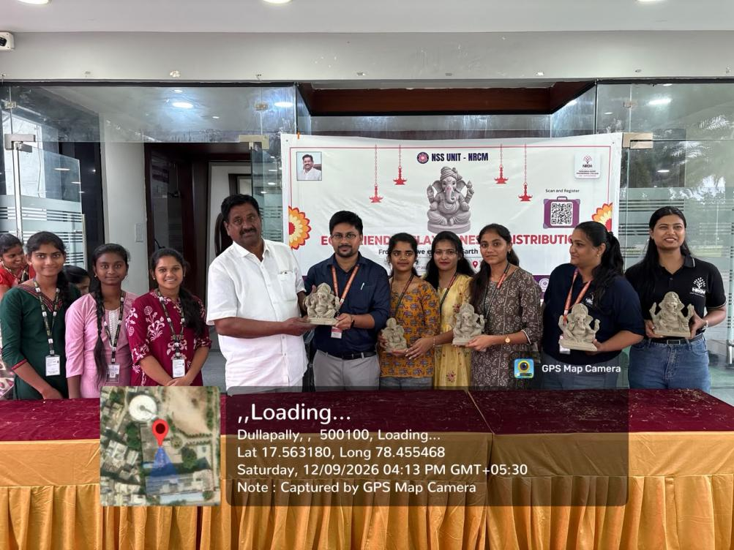
Event Photograph 10 |  | 